ELECTRIC PLAN - CNC PLASMA MACHINE
KOTEC KTPG-320 | Controller: UC300-5LPT + Mach3 | SOMIK Skikda
Client: | SOMIK Skikda - Skikda
Machine: | KOTEC KTPG-320 CNC Plasma Cutting Machine
Serial No: | 149P324050WYPV1K
Motion Controller: | UC300-5LPT (CNC Drive) via USB
Software: | Mach3 + UC300 Plugin
Date: | 20/07/2026

1. UC300-5LPT CONTROLLER OVERVIEW
Feature | Specification
Ports | 5x IDC-26 LPT ports + 1x IDC-16 analog port
Port types | Ports 2, 3 = standard LPT | Ports 1, 4, 5 = input type
Digital I/O | 49 inputs / 36 outputs (TTL 5V, 20mA max)
Analog | 2 analog inputs + 2 analog outputs
Step frequency | Up to 300 kHz per axis
Axes | Up to 6 (X, Y, Z, A, B, C)
PC connection | USB
Isolation | None on LPT ports - use opto-isolated drives

IMPORTANT: UC300 LPT pins are referenced to PC ground (no isolation). YPV servo drives have built-in opto-couplers - do NOT use a non-isolated breakout.
2. PORT 2 (STANDARD LPT) - MOTION CONTROL & PLASMA
Outputs: pins 1-9, 14, 16, 17 | Inputs: pins 10-13, 15 | Pins 18-25 GND | Pin 26 +5V
Pin | Signal | Type | Connected To
1 | X Step | Output | YPV Drive X - Pulse
2 | X Dir | Output | YPV Drive X - Direction
3 | Y Step | Output | YPV Drive Y - Pulse
4 | Y Dir | Output | YPV Drive Y - Direction
5 | Z Step | Output | YPV Drive Z - Pulse
6 | Z Dir | Output | YPV Drive Z - Direction
7 | Plasma Start | Output | HPR Ignition Console (078172)
8 | Torch Height Up | Output | Torch Height Control
9 | Torch Height Down | Output | Torch Height Control
10 | E-Stop | Input | Emergency Stop Button
11 | Probe | Input | Probe Sensor
12 | X Home | Input | X Home Switch
13 | Y Home | Input | Y Home Switch
14 | Coolant Pump | Output | Coolant Pump Relay
15 | Z Home | Input | Z Home Switch
16 | Fume Extractor | Output | Dust Collector Relay
17 | Air Valve | Output | Air Solenoid

3. PORT 3 (STANDARD LPT) - GAS CONTROL SYSTEM
Outputs: pins 1-9, 14, 16, 17 | Inputs: pins 10-13, 15 | Pins 18-25 GND | Pin 26 +5V
Pin | Signal | Type | Connected To
1 | Plasma Gas O2 Valve | Output | Gas Console (078532)
2 | Plasma Air Valve | Output | Gas Console (078532)
3 | Plasma N2 Valve | Output | Gas Console (078532)
4 | Shield O2 Valve | Output | Gas Console (078532)
5 | Shield Air Valve | Output | Gas Console (078532)
6 | Shield N2 Valve | Output | Gas Console (078532)
7 | Cut O2 Valve (Oxy-fuel) | Output | Stations 2/3/4
8 | Cut LPG Valve (Oxy-fuel) | Output | Stations 2/3/4
9 | Preheat O2 Valve | Output | Stations 2/3/4
10 | Arc OK | Input | HPR Power Supply
11 | Motion OK | Input | CNC Interface
12 | Pierce Complete | Input | HPR Power Supply
13 | Coolant Flow OK | Input | Coolant Flow Sensor
14 | Preheat LPG Valve | Output | Stations 2/3/4
15 | Gas Pressure OK | Input | Pressure Sensor
16 | Marking O2 Valve | Output | Gas Console (078532)
17 | Spare | Output | -

4. PORT 1 (INPUT TYPE) - OXY-FUEL STATIONS & LIMITS
Outputs: pins 1, 14, 16, 17 | Inputs: pins 2-13, 15 | Pins 18-25 GND | Pin 26 +5V
Pin | Signal | Type | Connected To
1 | Station 2 Select | Output | Oxy-fuel Station 2 Valve
2 | X+ Limit | Input | X Limit Switch
3 | X- Limit | Input | X Limit Switch
4 | Y+ Limit | Input | Y Limit Switch
5 | Y- Limit | Input | Y Limit Switch
6 | Z+ Limit | Input | Z Limit Switch
7 | Z- Limit | Input | Z Limit Switch
8 | Spare | Input | -
9 | Spare | Input | -
10 | Spare | Input | -
11 | Spare | Input | -
12 | Spare | Input | -
13 | Spare | Input | -
14 | Station 3 Select | Output | Oxy-fuel Station 3 Valve
15 | Spare | Input | -
16 | Station 4 Select | Output | Oxy-fuel Station 4 Valve
17 | Spare | Output | -

5. PORTS 4 & 5 (INPUT TYPE) - SPARE / FUTURE EXPANSION
All pins available for future sensors, MPG handwheel, additional inputs, etc.
6. ANALOG PORT (IDC-16)
Pin | Signal | Use
1, 8, 9, 16 | +12V Output | Potentiometer power
2, 5, 10, 13 | Ground | Ground reference
3 | Analog Input 1 | Feed Rate Override (pot)
4 | Analog Input 2 | Speed Override (pot)
6 | Analog Output 1 | Plasma Speed 0-10V (VFD)
7 | Analog Output 2 | Spare

7. WIRING DIAGRAM
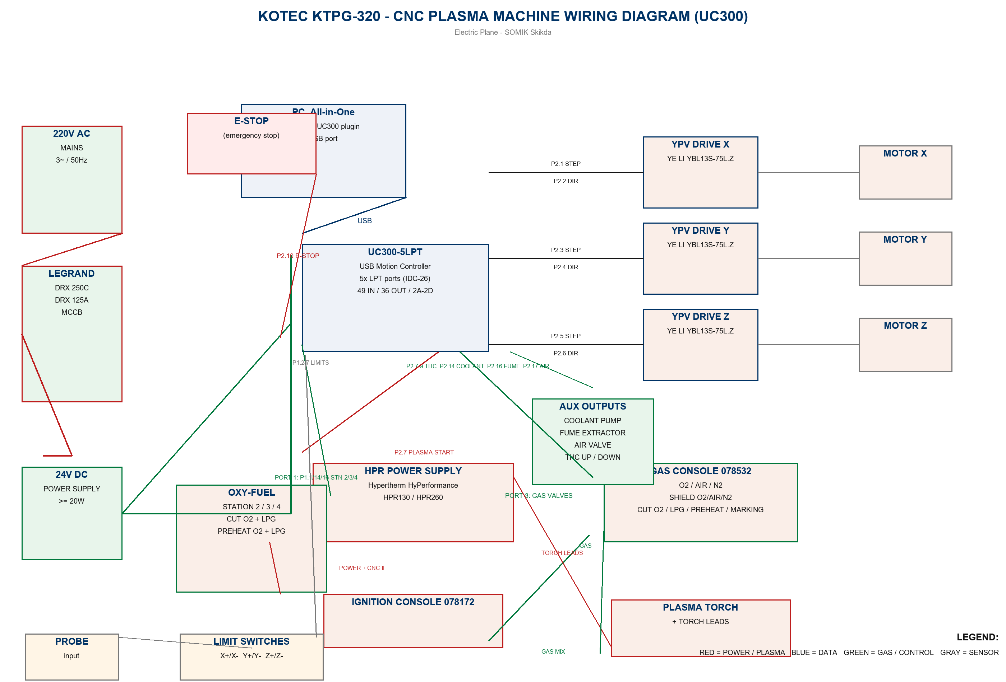
Wiring diagram is also available as separate file: Wiring_Diagram.png
8. POWER DISTRIBUTION NOTES
Circuit | Source | Destination
Mains | 220V AC 3~ | Legrand DRX 250C / DRX 125A breakers
Drives | After breakers | YPV servo drives (X, Y, Z)
Plasma | After breakers | HPR Power Supply
Controller | 24V DC PSU (>=20W) | UC300-5LPT
I/O | 24V DC | Input sensors / output relays (opto)

9. GENERAL NOTES
- All UC300 LPT I/O is 5V TTL, referenced to PC ground - external isolation required (use opto-couplers inside YPV drives and relays).
- Use shielded USB cable for PC to UC300 connection.
- Encoder/power cables from YPV drives to YE LI motors must be shielded and grounded at one end.
- E-Stop must interrupt power to drives AND be wired to Port 2 Pin 10 for software stop.
- Analog outputs are 0-10V - verify VFD/spindle input compatibility.
- This pin allocation can be edited freely in future - change assignments in Mach3 Config > Ports & Pins.

